***With record heat expected, these 5 maps show what’s to come across the U.S.***

The southern U.S. heat wave, remarkable for its size, intensity and duration, is predicted to expand

By [Dan Stillman](https://www.washingtonpost.com/people/dan-stillman/?itid=ai_top_stillmand0-v), Updated July 19, 2023 at 2:32 p.m. EDT|Published July 19, 2023 at 2:21 p.m. EDT

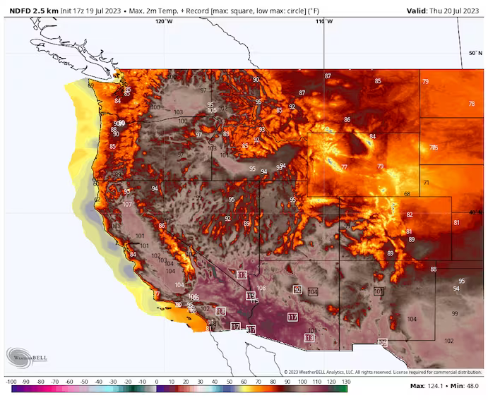

The [brutal heat wave](https://www.washingtonpost.com/weather/2023/07/18/heat-wave-southern-us-record-temperatures/?itid=lk_inline_manual_2) across the southern United States — remarkable for its size, intensity and duration — is still going strong, with little hope for significant relief. In fact, forecasts show the extreme heat expanding through this weekend, with approximately 80 million people experiencing a temperature or heat index above 105 degrees, according to the National Weather Service, and continuing well into next week.

Over the coming days, dozens of new record highs are forecast in the Southwest, while historically long streaks of extreme temperatures will grow. [Phoenix’s record streak](https://www.washingtonpost.com/weather/2023/07/18/phoenix-heat-wave-record-temperature-streak/?itid=lk_inline_manual_4) of 20 straight days reaching 110 degrees or higher could continue well into next week. The same is true both for El Paso’s streak of 34 consecutive days reaching 100 degrees or higher and [Miami’s 39 straight days with heat indexes over 100](https://bmcnoldy.rsmas.miami.edu/mia/).

Expect more nighttime heat records as well, such as the [all-time record warm low temperature](https://twitter.com/NWSPhoenix/status/1681678326845554688) of 97 degrees set by Phoenix on Wednesday morning.

These five maps help to show what is still to come in this scorching heat wave for the record books.

**The outlook is … HOT**

*Chance of above-normal, near-normal and below-normal temperatures July 24-28. (National Weather Service)*

Extreme heat, potentially including the extension of record hot streaks in Phoenix and El Paso, is likely to continue at least well into next week.

(The Washington Post)

*We’re tracking dangerous heat waves across the United States daily.*[*Look up your city to see extreme heat risks*](https://www.washingtonpost.com/weather/interactive/2023/heat-waves-map-us-tracker/?itid=cb_box_QV2IPSUWP5B2BAUDD5WTDG46AY_1)*near you.*

The National Weather Service’s Climate Prediction Center forecasts a high likelihood — a 60 to 90 percent chance — of above-normal temperatures across a large swath of the western half of the country and much of Florida in its six-to-10-day outlook issued Tuesday. The Weather Service describes “above normal” confidence in that [forecast](https://www.cpc.ncep.noaa.gov/products/predictions/610day/fxus06.html).

The [eight-to-14-day outlook](https://www.cpc.ncep.noaa.gov/products/predictions/814day/814temp.new.gif) offers little relief, with the chance of above-normal temperatures at 60 percent or higher for much of the South. The main shift for that period, July 26 to Aug. 1, is a slightly lower chance of above-normal temperatures in Arizona and central-to-southern California, but a higher chance for the Southeast.

**Huge heat dome is getting stronger**

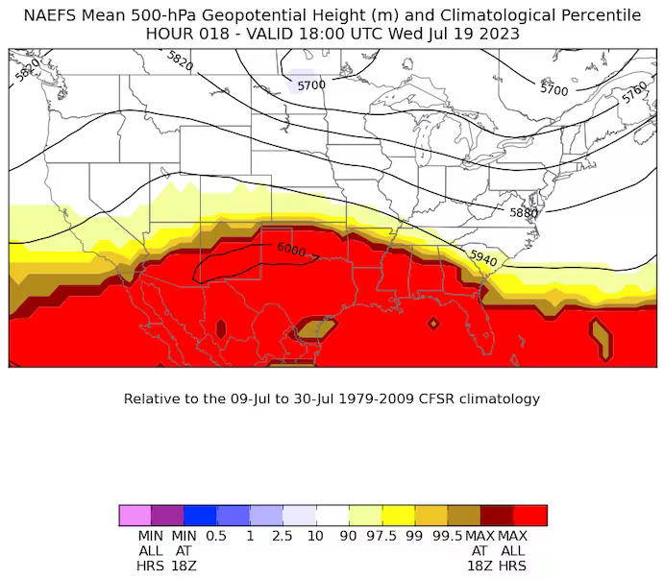  
*Model forecast of heat dome intensity, as indicated by pressure in the middle of the atmosphere, on Wednesday afternoon. (NOAA)*

The heat dome that has been a mainstay over the southern United States and northern Mexico for weeks is only intensifying. Heat domes are sprawling areas of high pressure that trap heat beneath them. The higher the pressure, the hotter the air underneath. Therefore, the intensity of a heat dome is measured by the pressure it exerts from above, and models predict this could be the most intense heat dome on record over the southern United States.

Aside from its intensity, the heat dome also covers a huge area stretching from well into the eastern Pacific Ocean eastward across the southern United States, all the way into the Atlantic Ocean. Pressure levels “across an incredibly expansive area of the subtropics and southern U.S. will be higher than at any time in the 1979-2009 climate model record,” [tweeted](https://twitter.com/GCarbin/status/1681329436107456512) Greg Carbin, the Weather Service’s chief of forecast operations.

The heat dome scorching the southern United States is one of [multiple heat domes occurring simultaneously](https://twitter.com/metoffice/status/1681273599561220098) around the world.

**Dangerous heat indexes predicted to expand**

*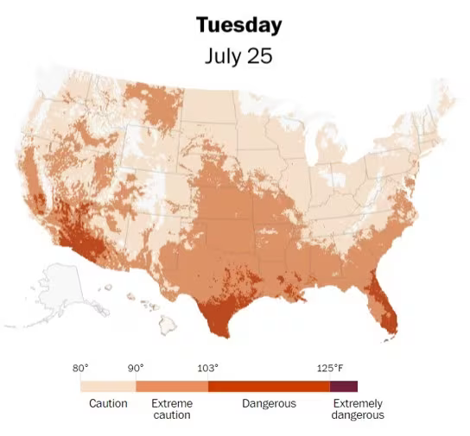  
Heat index forecast for July 25. (The Washington Post)*

High humidity has made the extreme heat especially dangerous. The heat index estimates how hot the air feels when factoring in the humidity. Heat indexes above 110 degrees have been common along the Gulf Coast and Southeast and have reached 120 degrees or higher in some locations. Dangerous combinations of heat and humidity are expected to continue at least well into next week, according to The Washington Post’s [heat tracker](https://www.washingtonpost.com/weather/interactive/2023/heat-waves-map-us-tracker/?itid=sf_weather_weather_heat-tracker_p001_f001&itid=lk_inline_manual_25), even expanding deeper into the south-central and southeast United States.

**More on the extreme heat waves**

[[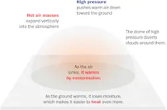](http://www.washingtonpost.com/weather/2023/07/21/us-heat-wave-heat-dome-climate/?itid=mc_magnet-extreme-heat_inline_collection_1)](http://www.washingtonpost.com/weather/2023/07/21/us-heat-wave-heat-dome-climate/?itid=mc_magnet-extreme-heat_inline_collection_1)*[Inside the most extreme heat wave the Southern U.S. has faced](http://www.washingtonpost.com/weather/2023/07/21/us-heat-wave-heat-dome-climate/?itid=mc_magnet-extreme-heat_inline_collection_1)*

[[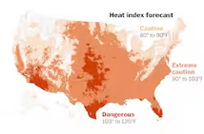](http://www.washingtonpost.com/weather/interactive/2023/heat-waves-map-us-tracker/?itid=mc_magnet-extreme-heat_inline_collection_2)](http://www.washingtonpost.com/weather/interactive/2023/heat-waves-map-us-tracker/?itid=mc_magnet-extreme-heat_inline_collection_2)*[Where extreme heat poses the biggest threat: Track your city](http://www.washingtonpost.com/weather/interactive/2023/heat-waves-map-us-tracker/?itid=mc_magnet-extreme-heat_inline_collection_2)*

[[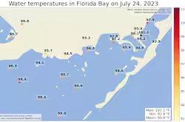](http://www.washingtonpost.com/weather/2023/07/25/florida-record-warm-ocean-climate/?itid=mc_magnet-extreme-heat_inline_collection_3)](http://www.washingtonpost.com/weather/2023/07/25/florida-record-warm-ocean-climate/?itid=mc_magnet-extreme-heat_inline_collection_3)*[In hot water: South Florida ocean tops 100 degrees; could be world record](http://www.washingtonpost.com/weather/2023/07/25/florida-record-warm-ocean-climate/?itid=mc_magnet-extreme-heat_inline_collection_3)*

[[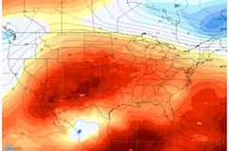](http://www.washingtonpost.com/weather/2023/07/24/us-heatwave-hottest-summer-climate/?itid=mc_magnet-extreme-heat_inline_collection_6)](http://www.washingtonpost.com/weather/2023/07/24/us-heatwave-hottest-summer-climate/?itid=mc_magnet-extreme-heat_inline_collection_6)*[This week will be the summer’s hottest so far over the Lower 48](http://www.washingtonpost.com/weather/2023/07/24/us-heatwave-hottest-summer-climate/?itid=mc_magnet-extreme-heat_inline_collection_6)*

[[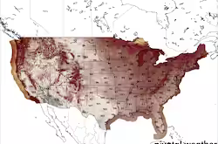](http://www.washingtonpost.com/weather/2023/07/21/heat-wave-record-temperatures-south-forecast/?itid=mc_magnet-extreme-heat_inline_collection_12)](http://www.washingtonpost.com/weather/2023/07/21/heat-wave-record-temperatures-south-forecast/?itid=mc_magnet-extreme-heat_inline_collection_12)*[More records will fall as brutal heat wave continues across southern U.S.](http://www.washingtonpost.com/weather/2023/07/21/heat-wave-record-temperatures-south-forecast/?itid=mc_magnet-extreme-heat_inline_collection_12)*

[[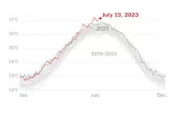](http://www.washingtonpost.com/weather/2023/07/20/earth-hottest-month-july-climate/?itid=mc_magnet-extreme-heat_inline_collection_15)](http://www.washingtonpost.com/weather/2023/07/20/earth-hottest-month-july-climate/?itid=mc_magnet-extreme-heat_inline_collection_15)*[We are living through Earth’s hottest month on record, scientists say](http://www.washingtonpost.com/weather/2023/07/20/earth-hottest-month-july-climate/?itid=mc_magnet-extreme-heat_inline_collection_15)*

“Take the heat seriously and avoid extended time outdoors. Temperatures and heat indices will reach levels that would pose a health risk, and be potentially deadly, to anyone without effective cooling and/or adequate hydration,” the Weather Service said.

**The heat is even worse in the sun**

**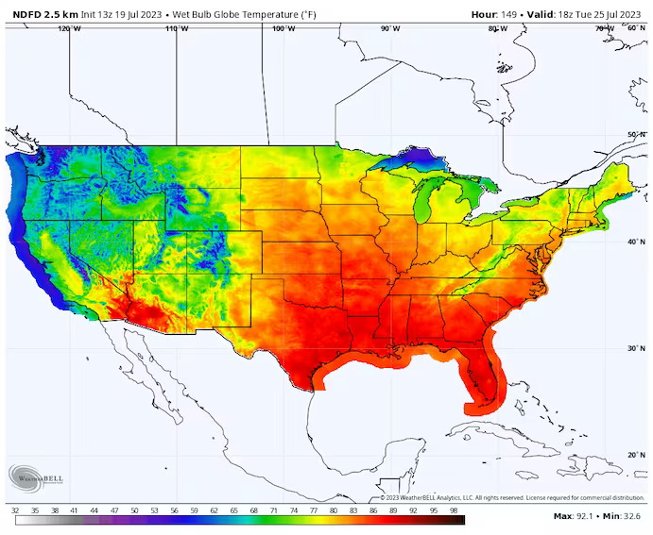***National Weather Service's wet bulb globe temperature forecast for the afternoon of July 25. (WeatherBell.com)*

The heat index most people are familiar with only factors in temperature and humidity and assumes you are in the shade. For those who work or exercise outside, the “wet bulb globe temperature” (WBGT) can be a more useful measure of how the heat affects your body.

Through early next week, WBGT levels are forecast to hover in the upper 80s in many parts of the southern states. At these levels, the American College of Sports Medicine advises canceling or at least limiting high-intensity activities.

The [WBGT is measured and predicted assuming direct sunlight](https://www.weather.gov/arx/wbgt#guidelines). It also takes into account wind speed, sun angle and cloud cover. Like the heat index, the WBGT is forecast to remain extremely high across much of the southern United States into next week.

[*The heat index reached 152 degrees in the Middle East — nearly at the limit for human survival*](https://www.washingtonpost.com/weather/2023/07/18/extreme-heat-record-limits-human-survival/?itid=lk_interstitial_manual_38)

**Climate change is intensifying the heat**

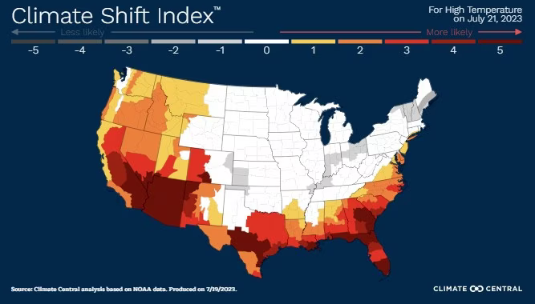  
*Climate Central's Climate Shift Index for Wednesday. (Climate Central)*

Climate change is making heat waves like the current one more likely, more frequent and more intense. Climate Central, a nonprofit science communication organization based in Princeton, N.J., attempts to capture the influence of climate change on extreme temperatures with its [Climate Shift Index](https://www.washingtonpost.com/climate-environment/interactive/2022/maps-heat-wave-climate-change-us/?itid=lk_inline_manual_68&itid=lk_inline_manual_41&itid=lk_inline_manual_41).

For predicted high temperatures on Friday, the 0-to-5 index registers at levels 3, 4 and 5 across much of the nation’s southern tier from Arizona to Florida. That means climate change is making the extreme heat at least three, four and five times as likely, according to the index. [Climate Central describes](https://www.climatecentral.org/tools/climate-shift-index) Level 4 conditions as “extremely rare without climate change” and Level 5 as “an exceptional event driven by climate change.”

**More on extreme heat**

**Our warming climate:**Here’s what to know about a sweltering [heat wave that isn’t moving anytime soon](https://www.washingtonpost.com/weather/2023/07/18/heat-wave-southern-us-record-temperatures/?itid=lb_more-on-extreme-heat_1). At Earth’s hottest spots, [heat is testing the limits of human survival](https://www.washingtonpost.com/weather/2023/07/18/extreme-heat-record-limits-human-survival/?itid=lb_more-on-extreme-heat_2). It’s not just you ⁠— [summers in the U.S. are getting hotter](https://www.washingtonpost.com/climate-environment/2022/07/02/summer-2022-climate-change-heat/?itid=lb_more-on-extreme-heat_3). [Look up your city to see your extreme heat risk](https://www.washingtonpost.com/weather/interactive/2023/heat-waves-map-us-tracker/?itid=lb_more-on-extreme-heat_4) with our tracker. Take a look at [what extreme heat does to the human body](https://www.washingtonpost.com/world/interactive/2021/climate-change-humidity/?itid=lb_more-on-extreme-heat_5).

**How to stay safe:**It’s better to prepare for extreme heat before you’re in it. Here’s our [guide to bracing for a heat wave](https://www.washingtonpost.com/climate-solutions/2022/07/19/heat-wave-tips-air-conditioning/?itid=lb_more-on-extreme-heat_6), tips for staying cool even if [you don’t have air conditioning](https://www.washingtonpost.com/lifestyle/2021/07/16/how-to-keep-cool-without-ac/?itid=lb_more-on-extreme-heat_7), and what to know about [animal safety during extreme heat](https://www.washingtonpost.com/nation/2021/07/24/experts-express-concerns-animal-safety-heat-waves-continue-rip-through-pacific-northwest/?itid=lb_more-on-extreme-heat_8). Traveling during a heat wave isn’t ideal, but [here’s what to do if you are](https://www.washingtonpost.com/lifestyle/travel/travel-driving-extreme-heat-wave/2021/06/23/9b6ea416-d03c-11eb-8014-2f3926ca24d9_story.html?itid=lb_more-on-extreme-heat_9).

**Understanding the science:** Sprawling zones of high pressure called heat domes fuel heat waves. [Here’s how they work](https://www.washingtonpost.com/weather/2021/07/10/heat-dome-heat-wave-faq/?itid=lk_interstitial_manual_63&itid=lb_more-on-extreme-heat_10). You can also read more about the [link between weather disasters and climate change](https://www.washingtonpost.com/climate-solutions/2020/10/22/climate-curious-disasters-climate-change/?itid=lb_more-on-extreme-heat_11), and how leaders in [the U.S. and Europe are responding to heat](https://www.washingtonpost.com/climate-environment/2022/07/19/heat-wave-europe-climate-change/?itid=lb_more-on-extreme-heat_12).